Online Book Publishing and Sales Platfrom - Database Documentation

Database name : Books_publishing_system



Creating Tables:



**CREATE TABLE Publisher(**

**publisher_id int primary key,**

**name varchar(250) not null,**

**contact_details varchar(250)**

**);**

Creating a Publisher Table and the columns are publisher_id data type Int (Primary key), name data type varchar, contact_details data type varchar.



**CREATE TABLE Book(**

**book_id int primary key,**

**title varchar(250) not null,**

**ISBL varchar(100) not null,**

**edition int not null,**

**publication_year int,**

**price decimal(10, 2),**

**publisher_id int,**

**foreign key (publisher_id) references Publisher(publisher_id) on delete cascade**

**);**

Creating a Book Table and the columns are book_id data type Int (Primary key), title data type varchar, ISBL data type Int, edition data type Int, publication_year data type Int, price data type decimal, publisher_id data type Int (Foreign key).



**CREATE TABLE Genere(**

**genere_id int primary key,**

**genere_name varchar(250) not null**

**);**

Creating a Genere Table and the columns are genere_id data type Int (Primary key), genere_name data type varchar.



**CREATE TABLE Book_genere(**

**book_id int,**

**genere_id int,**

**primary key(book_id, genere_id),**

**foreign key (book_id) references Book(book_id),**

**foreign key (genere_id) references Genere(genere_id)**

**);.**

Creating a Book_genere Table and the columns are book_id data type Int (Primary key and Foreign key), genere_id data type int(Primary key).



**CREATE TABLE Author(**

**author_id int primary key,**

**name varchar(250) not null,**

**biography text**

**);**

Creating a Author Table and the columns are author_id data type Int (Primary key), name data type varchar, biography data type text.



**CREATE TABLE Book_Author(**

**book_id int,**

**author_id int,**

**primary key (book_id, author_id),**

**foreign key (book_id) references Book(book_id),**

**foreign key (author_id) references Author(author_id)**

**);**

Creating a Book_author Table and the columns are book_id data type int (Primary key and Foreign key), author_id data type Int (Primary key and Foreign key) and this is a Junction Table.



**CREATE TABLE Customer(**

**customer_id int primary key,**

**name varchar(250) not null**

**);**

Creating a Customer Table and the columns are customer_id data type int (Primary key), name data type varchar.



**CREATE TABLE Address(**

**address_id int primary key,**

**customer_id int,**

**street varchar(250),**

**city varchar(250),**

**state varchar(250),**

**country varchar(250),**

**foreign key (customer_id) references Customer(customer_id)**

**);**

Creating a Address Table and the columns are address_id data type Int (Primary key), customer_id data type int (Primary key and Foreign key), street data type varchar, city data type text, state data type varchar, country data type varchar.

**CREATE TABLE Wishlist(**

**customer_id int,**

**book_id int,**

**primary key (customer_id, book_id),**

**foreign key (customer_id) references Customer(customer_id),**

**foreign key (book_id) references Book(book_id)**

**);**

Creating a Wishlist Table and the columns are customer_id data type Int (Primary key and Foreign key), book_id data type int (Primary key and Foreign key).



**CREATE TABLE Orderr(**

**order_id int primary key,**

**order_date date not null,**

**customer_id int,**

**payment_details varchar(250),**

**shipping_address_id int,**

**foreign key (customer_id) references Customer(customer_id),**

**foreign key (shipping_address_id) references Address(address_id)**

**);**

Creating a Orderr Table and the columns are order_id data type Int (Primary key),order_date data type date, customer_id data type int (Primary key and Foreign key), payment_details data type varchar, shipping_address_id data type int(Foreign key).

**CREATE TABLE Order_book(**

**Orderitem_id int primary key,**

**order_id int,**

**book_id int,**

**quantity int not null,**

**foreign key (order_id) references Orderr(order_id),**

**foreign key (book_id) references Book(book_id)**

**);**

Creating a Order_book Table and the columns are orderitem_id data type Int (Primary key),order_id data type (Foreign key), book_id data type int (Foreign key), quantity data type int.



Inserting data into Tables:



**INSERT INTO Publisher (publisher_id, name, contact_details)**

**VALUES**

**(1, 'Penguin Random House', 'contact@penguin.com'),**

**(2, 'HarperCollins', 'support@harpercollins.com');**

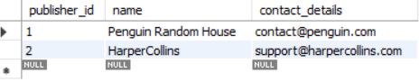

**INSERT INTO Book (book_id, title, ISBL, edition, publication_year, price, publisher_id)**

**VALUES**

**(1, 'The Silent Patient', '9781250301697', 1, 2019, 499.99, 1),**

**(2, 'Atomic Habits', '9780735211292', 1, 2018, 399.50, 2),**

**(3, 'Clean Code', '9780132350884', 2, 2008, 699.00, 1);**

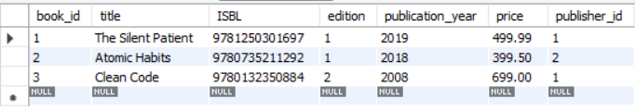



**INSERT INTO Genere (genere_id, genere_name)**

**VALUES**

**(1, 'Thriller'),**

**(2, 'Self-help'),**

**(3, 'Programming');**

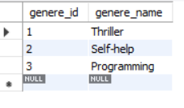

**INSERT INTO Book_genere (book_id, genere_id)**

**VALUES**

**(1, 1), -- The Silent Patient -> Thriller**

**(2, 2), -- Atomic Habits -> Self-help**

**(3, 3); -- Clean Code -> Programming**

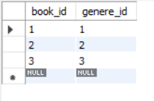



**INSERT INTO Author (author_id, name, biography)**

**VALUES**

**(1, 'Alex Michaelides', 'British-Cypriot author.'),**

**(2, 'James Clear', 'Speaker and writer on habits.'),**

**(3, 'Robert C. Martin', 'Also known as Uncle Bob, software engineer.');**

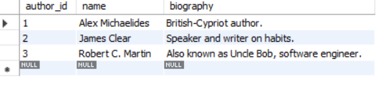

**INSERT INTO Book_Author (book_id, author_id)**

**VALUES**

**(1, 1), -- The Silent Patient -> Alex**

**(2, 2), -- Atomic Habits -> James**

**(3, 3); -- Clean Code -> Robert**

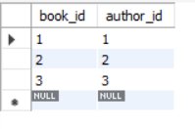



**INSERT INTO Customer (customer_id, name)**

**VALUES**

**(1, 'Rachel Green'),**

**(2, 'Monica Geller');**

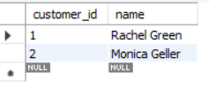

**INSERT INTO Address (address_id, customer_id, street, city, state, country)**

**VALUES**

**(1, 1, '123 Park Ave', 'New York', 'NY', 'USA'),**

**(2, 2, '456 Central Perk', 'New York', 'NY', 'USA');**

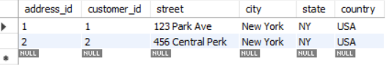



**INSERT INTO Wishlist (customer_id, book_id)**

**VALUES**

**(1, 2), -- Rachel -> Atomic Habits**

**(1, 3), -- Rachel -> Clean Code**

**(2, 1); -- Monica -> The Silent Patient**

**(3, 'Clean Code', '9780132350884', 2, 2008, 699.00, 1);**

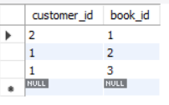

**INSERT INTO Orderr (order_id, order_date, customer_id, payment_details, shipping_address_id)**

**VALUES**

**(1, '2025-06-01', 1, 'Credit Card', 1),**

**(2, '2025-06-02', 2, 'PayPal', 2);**

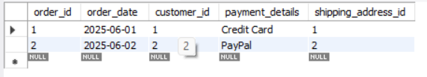



**INSERT INTO Order_book (Orderitem_id, order_id, book_id, quantity)**

**VALUES**

**(1, 1, 2, 1), -- Rachel ordered Atomic Habits**

**(2, 1, 3, 1), -- Rachel also ordered Clean Code**

**(3, 2, 1, 2); -- Monica ordered 2 copies of The Silent Patient**

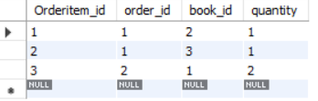

**ER Diagram:**

